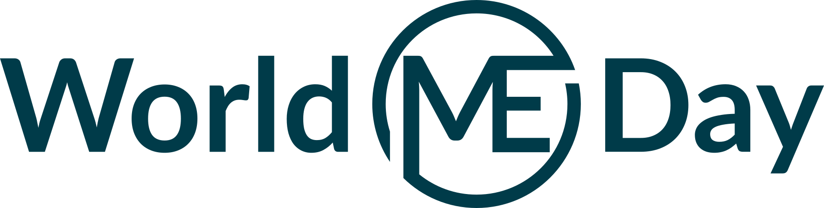
FOR IMMEDIATE RELEASE – May 12, 2023

Contact: INSERT YOUR NAME OR ORGANIZATION NAME AND EMAIL OR PHONE NUMBER

World ME Day raises awareness of devastating symptom impacting millions post-COVID

Twenty-two organizations from around the world unite to promote awareness of ME - the disease where pushing harder can make you sicker.

May 12, 2023 – To mark World ME Day on May 12, 2023, the World ME Alliance and its 22 member organizations are proud to announce the launch of a global awareness campaign addressing the hallmark symptom of ME: post-exertional malaise (PEM) and using the tagline “ME: the disease where pushing harder can make you sicker.”

It is estimated that between 17-30 million people live with ME worldwide. However since the COVID-19 pandemic hit, this figure is thought to have doubled. There are now 65 million people living with long COVID worldwide, and half of those meet the criteria for an ME diagnosis.
Myalgic encephalomyelitis (ME) is a disabling, chronic and complex disease. There is no diagnostic test, cure, nor universally effective treatments for ME, and patients often suffer for life.

The hallmark symptom of ME is post-exertional malaise (PEM) – a worsening of symptoms after physical, mental, or emotional exertion that would not have caused a problem before the illness. For some patients, sensory overload (light and sound) can induce PEM. These episodes are sometimes referred to as “crashes," and may last days, weeks, or permanently.

[Share what is happening for World ME Day near you in a quote, or ask a local person with ME to describe the impact of PEM on them]

For World ME Day this year, the World ME Alliance campaign aims to ensure the harmful effect of pushing harder is the first thing that comes to mind when someone hears about ME.

World ME Alliance co-chair and Solve M.E. CEO Oved Amitay notes, “Post-exertional malaise is a devastating symptom of both ME and Long Covid that is far too often disregarded or incorrectly managed by health care providers. PEM is a varying symptom that is challenging to recognize, and doing so requires intense listening to the person experiencing it. It is vital for health care professionals to identify PEM, as its presence changes the management advice a patient should be given and indicates that a diagnosis of ME should be considered. To avoid prolonging and intensifying the suffering of millions, providers must listen to and believe those who experience PEM.”
Patients from around the world are encouraged to share their PEM stories on social media and with local press, and to get involved with their national ME organizations. “If we listen to the lived experience of those with PEM, we can #LearnFromME,” says Amitay.
To find out more about ME or take a #LearnFromME action to support the cause, visit www.worldmeday.org

About the World ME Alliance:
The World ME Alliance is composed of ME organizations from around the world. Its membership is made up of senior leads/representatives from national ME organizations, working together to achieve change for people with ME at a national and international level.
To learn more about the World ME Alliance, visit www.worldmealliance.org. Contact the World ME Alliance via email and follow the Alliance on Facebook or Twitter.

For media inquiries only, contact:
NAME
EMAIL
PHONE

Information for the editor:
- Information about ME is available here.
- Factsheet on ME and PEM is available here.
- Information about World ME Day is available at worldmeday.org
- Stock photos – use appropriate images to help decrease stigma. A selection is available on Getty here.
- Royalty free photos depicting severe ME are available here.

